**Rectangular notch**

Apparatus used:

Rectangular notch, V-notch, hook gauge, measuring scale etc.

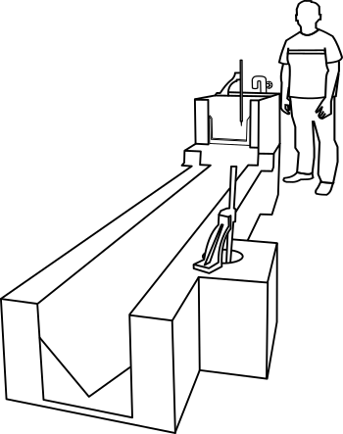

**STEP:➊**Start the pump by pressing start button.

**STEP:❷** Open the inlet valve and allow the water to fill in the channel till crest level.

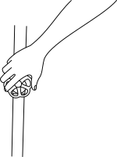

**STEP:➌** Note thedischarge reading of the rectangularnotch.

Initial reading (water level till crest) =_____cm

Final reading=_____cm

Head of water=_____ cm

Theoretical discharge, Qth=_____cm3/sec

**STEP:➍** Note the discharge reading of the V-notch.

Initial reading (water level till crest) =_____cm

Final reading=_____cm

Head of water=_____ cm

Actual discharge, Qact=_____cm3/sec

|  |  |  |  |  |  |  |  |  |  |  |
| --- | --- | --- | --- | --- | --- | --- | --- | --- | --- | --- |
| Sr. No. | Rectangular notch | | | V-notch  Hook gauge reading | | | (cm) | V-notch discharge  (m3/sec) | Rectangular notch (m3/sec) |  |
| I.R | F.R | F.R-I.R | I.R | F.R | F.R-I.R |
| 1 | 4.6 | 13.36 | 8.76 | 5.87 | 17.45 | 11.58 | 13.348 | 6466.08 | 10219.52 | 0.6327 |
| 2 | 4.6 | 12.26 | 7.66 | 5.87 | 16.50 | 10.63 | 13.568 | 5220.39 | 8494.1 | 0.6146 |
| 3 | 4.6 | 11.36 | 6.76 | 5.87 | 15.79 | 9.92 | 13.748 | 4391.87 | 7135.39 | 0.6155 |
| 4 | 4.6 | 10.34 | 5.74 | 5.87 | 14.83 | 8.96 | 13.952 | 3405.18 | 5665.82 | 0.6010 |
| 5 | 4.6 | 9.16 | 4.56 | 5.87 | 13.64 | 7.77 | 14.188 | 2384.64 | 4079.69 | 0.5845 |
| 6 | 4.6 | 8.49 | 3.89 | 5.87 | 12.99 | 7.12 | 14.322 | 1916.77 | 3244.79 | 0.5907 |
| 7 | 4.6 | 7.85 | 3.25 | 5.87 | 12.17 | 6.30 | 14.450 | 1411.63 | 2500.06 | 0.5646 |

OBSERVATION:

Length of rectangular notch = 15.1 cm

No. of end contractions, n=2

Angle of V-notch = 90o

Co-efficient of discharge for V-notch = 0.6

Result:

Coefficient of discharge,Cd= _____

CALCULATION:

Head at the rectangular notch,H = _____cm

Head at the V-notch, h = _____cm



= _____cm

Actual discharge, 

= _____cm3/sec

Theoretical discharge, 

= _____cm3/sec

Coefficient of discharge, 

=_____